RURAL STRAND

COMMUNITY ENGAGEMENT

Document Control

Document Purpose
The purpose of this document is to provide a framework for community engagement in the rural parishes and benefices of the Diocese of Newcastle.

Contact Details
Authors(s) | Jonathan Mason

Document History
Version | Date Updated | Updated by | Reason
0.a | 15/12/2018 | Jonathan Mason | Initial draft

Document Review
Name | Role | Responsible/  Accountable/  Consulted/  Informed | Version | Date

Contents
1 Document Control 2
1.1 Document Purpose 2
1.2 Contact Details 2
1.3 Document History 2
1.4 Document Review 2
2 Summary 4
3 Background 4
3.1 Context 4
3.2 Opportunities 4
3.3 Challenges/threats 4
4 Objectives 4
5 Outcomes 5
6 Description 5
7 Risks/Dependencies/Assumptions 6
7.1 Key Risks 6
7.2 Key Dependencies 6
7.3 Key Assumptions 7
8 Resources 7
9 Stakeholder Engagement 7
APPENDICES 9
I. ??? 10

Summary
Within the Rural Strand of the diocesan strategy, growing church bringing hope, a wealth of already existing experience and expertise will be brought together with a renewed vision for community engagement in rural communities, in partnership with private, public and community bodies.
Both rural churches and many of the rural communities in which they are placed are facing issues of sustainability. The Rural Strand aims to enable churches and communities to be generous, engaged and open, confident in the future.
Collaborative ministry is a key element in the Rural Strand, with Mission and Ministry teams of lay and ordained people working across traditional parish boundaries. That collaborative impetus, built on relationships of trust and a shared vision, will be crucial to the success of churches engagement with the wider community.

Background

Context
The Rural Strand of Growing Church Bringing Hope aims to re-imagine rural ministry, particularly to create mission and ministry teams with new pastoral structures. These need to be responsive to local need, making use of a variety of models and kinds of lay and ordained ministers and workers as appropriate, and be resilient, enabling a sustainable, positive church presence in every rural community. In order to assess the impact of these interventions within a given change arena, a monitoring and evaluation process is required. Learning from evaluation will allow the deployment models to be refined in support of the desired outcomes.

Opportunities
- To re-imagine the Church's engagement with the communtiy through shared learning from the case studies established within the Rural Strand and work in other change arenas. Within the diocese.
- To consolidate and develop partnerships with community and statutory bodies: locally, at diocesan and regional level, and nationally, in order to better enable rural Mission and Ministry Leadership Teams (MMLTs) for the work of community engagement.
- To create a network of expertise and experience within and across the diocese that could provide support for rural MMLTs.

Challenges/threats
- Ageing demographic

Objectives
The goals for the strategy are that in five years’ time the rural church will be:
- Worshipping locally and with openness to new patterns of worship, new styles of worship and fresh types of congregation;
- Confident and engaged with developing the church’s life and mission (this will include training for lay and ordained, the development of discipleship, the nurture of lay worship leaders and the growth of clergy able to focus on delivering the vision;
- Regarded by other institutions, communities and individuals as a significant partner/player in the development of local communities;
- Valued – by itself and others – as a sacred space that holds and shares the Christian story and its heritage in Northumbria and beyond;
- A church that has embraced a holistic and varied understanding and practice of growth: in numbers of people who value, respect and engage with their parish church; in numbers of those who are positively impacted by the church; and in openness to how church growth might happen.

Outcomes
<what are the outcomes and how will we measure it>

Description
A theology of community engagement arises from relationship, which is at the heart of God: the divine economy of Father, Son, and Holy Spirit – Creator, Redeemer, and Sanctifier. It is built on God's engagement with the world through the Incarnation, an engagement with the world as it is, not just as it should be. It also acknowledges that every person is made in the image of God.
Therefore, community engagement begins with relationships; before any action can be taken, relationships of trust must be nurtured, through face-to-face meeting and listening. Once such relationships have been established then a vision for action can be developed. As God in Christ engaged with the world as it is, so the Church and its community partners must be realistic about the world as it is in individual settings. Many of the issues facing communities will be similar, but the nuances of particular locations and demographics must be carefully identified and assessed.
Any list of issues in rural areas of the Diocese of Newcastle might include:
- Community life: the sustainability of rural communities in terms of an ageing demographic and the difficulty of access to services.
- Pastoral care: isolation and loneliness, especially but not exclusively in scattered, more sparsely-populated areas.
- Rural business: the need for an adequate communications infrastructure (reliable, high-speed broadband and mobile phone coverage).
- Farming: an understanding of the working lives and concerns of farming communities.
- Environment: connecting people and nature; benefits to mental and spiritual health.
A theology of creation impacts on a theology of community engagement. The relationship between God and humanity is one in which human beings are tasked with sharing in the work of creation, a work which recognises that everyone has gifts, that each person in a community has something to contribute. In terms of community engagement, this means working in relationship to change communities for the better: seeking to improve the lives of all through creative action, seeking first the kingdom of God. There should be a difference in the community because the church exists, but the manner of engagement should always be 'doing with' not 'doing to' or 'doing for': the mission is God's mission.
An obvious first step to engaging in God's mission is to define success: bringing hope must mean lives being transformed by the power of Christ, though this will not appear in a readily identifiable form on balance sheets and annual statistical returns; not at first, anyway.
A second step is adequate preparation. Benjamin Franklin was surely right: 'by failing to prepare, you are preparing to fail'. Training, dealt with in another foundational document, is of crucial importance: training for members of MMLTs; training for all involved in engagement of any kind.
A third step is for the church in rural communities to look outward: to engage with all the people in a community; above all, to listen attentively; to listen with, as St Benedict puts it, 'the ear of the heart'.
Liveability and the Church Urban Fund have warned of the dangers inherent in a 'service delivery model' of community engagement, urging churches 'to resist the tendency to define people exclusively by their needs and problems, and the temptation to believe that service providers are uniquely able to help and support others'. The alternative suggested in their report, Fullness of Life Together: Reimagining Christian engagement in our communities, is the model of Asset-Based Community Development (ABCD) which it describes as 'a decisive move away from viewing service provision as an answer to the issues facing communities. Instead it seeks to strengthen communities and rebuild associational life at the neighbourhood level so that communities are once more able to meet their own needs'.
Relationships build community and those who live in any community, be it any of the many shades of rural or urban, must be connected, not as recipients but as partners. Churches will engage with a wide range of partners in the work of community engagement:
- Rural Strand Guiding Coalition
- Rural Conversations Network
- Parish Councils
- Northumberland County Council
- Northumberland National Park
- North Pennines AONB
- Northumberland Coast AONB
- The National Trust
- Farming Community Network (FCN)
- Royal Agricultural Benevolent Institution (RABI)
- Northumbria Police

Risks/Dependencies/Assumptions

Key Risks
Description | Importance | Mitigation | Owner
 | Low/Med/High

Key Dependencies
Dependency Description | Importance | Mitigation
 | Low/Med/High

Key Assumptions
Assumption Description | Importance | Mitigation
 | Low/Med/High

Resources
<what are the key resources required to deliver this strategy>

Stakeholder Engagement
The key stakeholders have been identified and assessed based upon their level of interest and the level of influence they exert in achieving the stated outcomes.
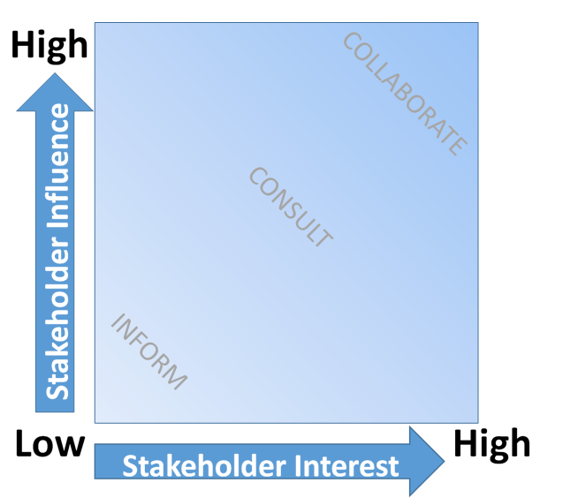
Stakeholder | Interest | Influence | Engagement Strategy
Name | LOW/MED/HIGH | LOW/MED/HIGH | How to engage and communicate with

APPENDICES

???

The Rule of St Benedict, Prologue, 1
https://livability.org.uk/
https://www.cuf.org.uk/
Fullness of Life Together: Reimagining Christian engagement in our communities, Liveability and The Church Urban Fund, 2015; Executive Summary, p.4

