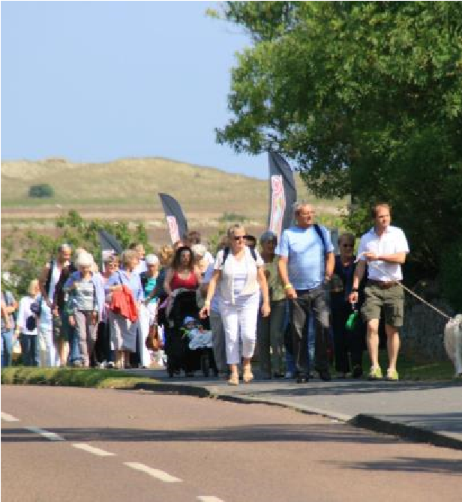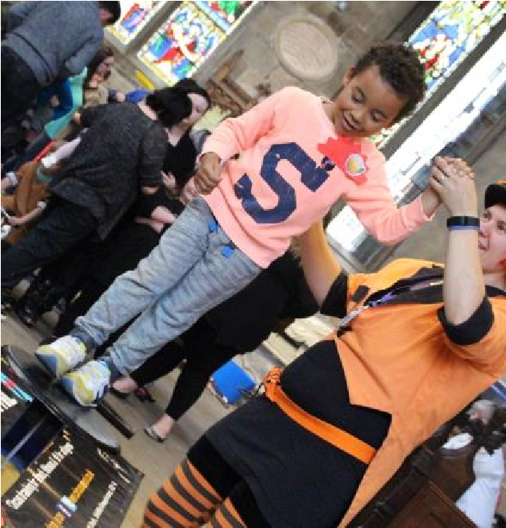Diocese of Newcastle www.newcastle.anglican.org

Rural Churches for Everyone Project Manager

(0.6
FTE
)

Diocese of Newcastle

Newcastle Diocesan Board of Finance. A Company Limited by Guarantee and a Registered Charity.
Registered in England number 650977. Registered office: Church House, St John’s Terrace, North Shields NE296HS.

Rural Churches for Everyone Project Manager
Background to the Post
This post is to manage the ‘Rural Churches for Everyone: Supporting Collective Futures for Church Buildings, Heritage and Communities in Northumberland’ project. Initially a 2 year project, it has now been extended to September 2022 as a result of delays due to Covid. The project is funded by the National Lottery Heritage Fund’s Places of Worship: Inspiring Ideas initiative which is exploring new ways of helping places of worship become more resilient and adapt to their changing environment.

The future and sustainability of rural churches is a national issue and is also a key objective of the rural strand of Newcastle Diocese’s current ‘Growing Church Bringing Hope’ change programme. Against this background, Rural Churches for Everyone will use an innovative group-based approach to support and strategically develop four clusters of Church of England churches in rural Northumberland as integrated community assets (c40 historic churches in total). The emphasis on working with groups of churches reflects the experience of previous church building support and development projects in the North East where the limited capacity of individual church management teams has been a big challenge even when significant professional support has been made available.

Within Rural Churches for Everyone, each church group will have a team consisting of clergy, church and community volunteers drawn from churches across the group. Each project team will be supported via an intensive consultancy programme to develop a strategy and business plan for the care and development of the churches in their group, and two members of each team will receive additional training enabling them to provide direct church buildings support to churches within their group. In addition, one church in each group will deliver a building improvement project (intended to ‘kick start’ the change and strategic development process across the group), and eight churches will achieve an equivalent of the Community Action Northumberland’s facilities ‘Hallmark’ standard.

The project is being led by Newcastle Diocese via the Project Manager and delivered in partnership with Community Action Northumberland, Newcastle University Centre for Rural Economy, North Pennines Area of Outstanding Natural Beauty, Northumberland Coast Area of Outstanding Natural Beauty and Northumberland National Park. Project delivery will be undertaken by the partners with additional support from a Strategic and Business Development consultant. The project will also develop and test new approaches to evaluation, including co-learning with other Inspiring Ideas projects around the UK.

Diocesan Background
The simple yet profound values of the Diocese of Newcastle – generous, engaged, and open - have become not only a way of expressing the aspirations of the Diocese but a prism through which we view our mission. They inform and inspire the way we work and our behaviour.
Framed by the Rivers Tyne and Tweed the Diocese of Newcastle is the Church of England’s most northerly diocese. This Diocese in the ‘land of the Northern Saints’ was formed in 1882 and comprises 172 parishes across 2,110 square miles. The Diocese covers the local authorities of Northumberland, Newcastle, North Tyneside and also small parts of County Durham and Cumbria. The 12 deaneries within 2 archdeaconries serve a population of 800,000 people across a variety of communities ranging from sparse rural to large inner city areas of deprivation.
A cohort of 83 stipendiary and 50 self-supporting clergy under the episcopal leadership of a diocesan bishop, the Rt Revd Christine Hardman, and the suffragan Bishop of Berwick, the Rt Revd Mark Wroe, are resourced by a team of lay and ordained supporting ministers, 25 active local ministry development groups and 137 readers. A small administration team is based at Church House, North Shields which also houses the Joint Education Team, the Lindisfarne Regional Training Partnership (two joint working initiatives with the Diocese of Durham) and a Religious Resources Centre.
The Diocese of Newcastle is committed to flourishing churches and communities and has developed a vision for growing church bringing hope as part of a response to the challenges faced by the church in our rural, urban and suburban settings.

Employment
The successful candidate will be employed by the Newcastle Diocesan Board of Finance (NDBF). It may be possible for this project work to be undertaken on a self-employed freelance worker basis.

Location
This post will be located at Church House, St John’s Terrace, Percy Main, North Shields NE29 6HS. The post holder will be required to travel extensively within the Diocese. In some circumstances home working may be considered.

Accountability and key relationships
Line Manager: Strategy & Transformation Programme Manager. Other key relationships: Project Steering Group, project partners, clergy and lay stakeholders, project team members, Diocesan colleagues (Diocesan Secretary, Communications and Finance Teams, Archdeacon of Lindisfarne, Senior Project Manager), consultants and specialist contractors.

Key Responsibilities
Project Management | • | Manage the delivery and legacy phases for the Rural Churches for Everyone project;
 | • | Manage and coordinate specialist contractors/consultants and co-ordinate with consultants and partners;
 | • | Build and maintain effective working relationships with key project partners;
 | • | Produce and maintain, in partnership with stakeholders, the detailed project control documents including schedule, scope, finance, risk register;
 | • | Produce and maintain detailed project documentation on both shared project google-drive and NDBF filing systems;
 | • | Produce and disseminate project reports for funders, stakeholders Steering Group and Project Board;
 | • | Support the development and implementation of the practical improvement works to be undertaken at four of the project churches;
 | • | Coordinate the project evaluation;
 | • | Coordinate and prepare agendas and papers from project meetings including Steering Group and working boards/groups.
Training and Project Support | • | Organise, administer and manage the project training/workshop programme;
 | • | Undertake training delivery where appropriate (in conjunction with partners and consultants);
 | • | Organise and manage the strategic development and business planning support programme for the four church groups (attend, provide support, advice and guidance as appropriate);
Finance | • | With the support the line manager, monitor and manage the project finances including budgeting, invoicing forecasting and tracking actuals;
Communications | • | Co-ordinate and collaborate with stakeholders to prepare project publicity, including promotional and engagement resources across the project churches;
 | • | Establish effective organisation and communication structures to meet the needs of stakeholders; produce and manage the communication plan for the project.
 | • | Lead on communications with HLF including monitoring meetings, monthly reports and grants requests.

Person Specification - Key Criteria
Qualifications & Training | • | The post holder will be educated to degree level or an equivalent qualification, and/or have demonstrable experience in conservation, historic building management, heritage and community project working/working with places of worship.
Experience | • | Ability to manage significant geographically dispersed, collaborative projects (financial and people) working across disciplines to deliver key outcomes on time and within budget;
 | • | Proven experience of managing and collaborating with people, both paid colleagues, partners and volunteers;
 | • | Evidence of financial acumen: previous experience of developing and managing significant budgets;
 | • | Managing specialist contractors and project managing staff and volunteers;
Knowledge & Skills | • Ability to lead, encourage and motivate others  • Experience of recruiting, training, supporting and leading teams of volunteers  • Able to lead and manage meetings;  • Evidence of ability to work collaboratively; good listening and facilitation skills;  • Able to manage a demanding workload;  • Strategic thinker, evidence of intellectual thinking and agility;  • Able to demonstrate self-awareness and emotional intelligence;  • Able to exercise sound judgement and effective decision making;  • Able to confront and manage conflict in an effective way;  • Able to build and maintain effective working relationships;  • Understanding of accessibility and equality issues and how they affect barriers to participation;  • Understanding of the Church of England’s commitment to Net Zero Carbon by 2030;  •Understanding of the relationship between Church Mission and Church buildings;  • Excellent IT skills, including MS Office (Word and Excel) and Google Suite IT skills;  • Able to use and host video conferencing.  • Empathy with the aims and objectives of the Diocese
Personal | • | Personal credibility and gravitas;
 | • | An excellent team player;
 | • | A flexible attitude;
 | • | Motivated self-starter;
 | • | Able to demonstrate enthusiasm, resilience and tenacity;
 | • | Able to embrace change;
 | • | Strong interpersonal skills.
General | • | Ability to work flexible hours, including evening and occasional weekend commitments as required.
 | • | Driving licence and access to a car.
Desirable | • | Hold or be working towards a recognised Project Management qualification, e.g. Prince 2

General Conditions

Diversity

We understand the benefits of employing individuals from a range of backgrounds, with diverse cultures and talents. We aim to create a workforce that:
- values difference in others and respects the dignity and worth of each individual;
- reflects the diversity of the nation that the Church of England exists to serve;
- fosters a climate of creativity, tolerance and diversity that will help all staff to develop to their full potential.
We are committed to being an equal opportunities employer and ensuring that all employees, job applicants, customers and other persons with whom we deal are treated fairly and are not subjected to discrimination. We want to ensure that we not only observe the relevant legislation but also do whatever is necessary to provide genuine equality of opportunity. We expect all of our employees to be treated and to treat others with respect. Our aim is to provide a working environment free from harassment, intimidation, or discrimination in any form which may affect the dignity of the individual.

Standards of Behaviour and Conduct

Employees are expected to act at all times with due consideration for others and in a manner befitting their position as employees of the Church and as professionals, whatever their job.

Health and Safety Responsibilities

The Newcastle Diocesan Board of Finance takes Health and Safety at work very seriously and require their employees to familiarise themselves with, and follow, their policy.

Terms and Conditions of Employment

Salary | Grade 4 Salary: probationary period £19,042 pa (£31,737 pa FTE); on completion of probationary period £20,045 pa (£33,408 pa FTE).
Pension Contributions | Employees will be automatically enrolled into the Church Workers Pension Fund (CWPF) Pension Builder Classic Scheme. The Newcastle Diocesan Board of Finance contributes 10% of pensionable salary as an employer contribution to the Scheme. This is a non-contributory Scheme and staff may voluntarily contribute to the Scheme if they wish to do so. Employees have a right to opt out of the Scheme after enrolment.
Hours of Duty | The post is offered on a part-time basis working the equivalent of 22.5 hours per week. This will consist of 11.25 core hours per week (days to be agreed) along with variable reserve hours to manage the peaks and troughs of project delivery. The role equates to an overall annualised role of 0.6 FTE.  The post requires availability and attendance at evening and weekend meetings and events.  Overtime is not paid but time off in lieu is provided. Lunch and any other breaks are unpaid.
Annual Leave | The leave year runs from 1st January to 31st December. Full-time staff receive 25 days paid leave per leave year exclusive of 8 public holidays and 4 additional holidays approved by the Board. The leave entitlement is pro rata for part time staff.
Contract | The employer is the Newcastle Diocesan Board of Finance.  The post is temporary for 15 months and is subject to a six month probationary period.

Application and Selection Process

Closing date for receipt of applications: 10.00 am Monday 21st June 2021. The selection process, which will include an interview and presentation, is scheduled for the week commencing 28th June 2021. It is expected that interviews will be held over Zoom.

You should e-mail your completed application form to recruitment@newcastle.anglican.org.

