Week commencing Sunday 29th March 2020
Faith at Home – The story of Lazarus

Let’s pray together:
Lord Jesus, We come together as your family, so that we can grow together in you.
We come together to say thank you.
We come together to ask for God’s help.
We come together to hear God’s story.

We come together to celebrate God’s love.

God is here, God is with us.

Amen.

Let’s read a bible story together: John 11: 1-45

Build the story!

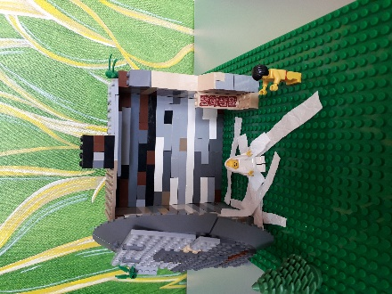
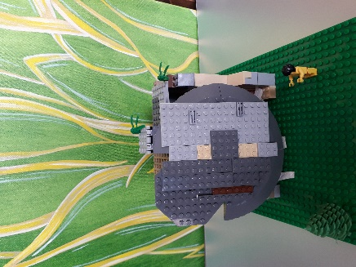
Build this week’s story out of Lego, Playmobil, recycling, junk or anything else you have at home and send your pictures to our Facebook page!

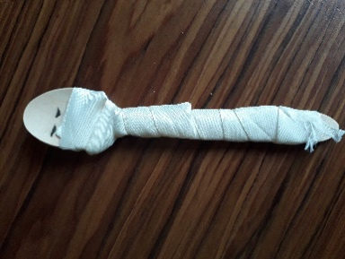
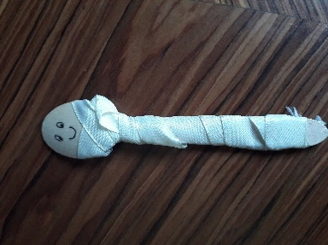
Let’s make: Lazarus come back to life
You will need: a wooden or plastic spoon and some ribbon or tissue paper and felt tip pen to draw face.
Draw a face with eyes closed on one side of the spoon and happy face with eyes wide open on the other side. Start with the spoon showing closed eyes and tell the story. When Lazarus dies in the story, wrap the ribbon or tissue paper around the spoon. When Lazarus is alive again in the story, take off the ribbon and turn the spoon to show the happy face

Creative prayer activity
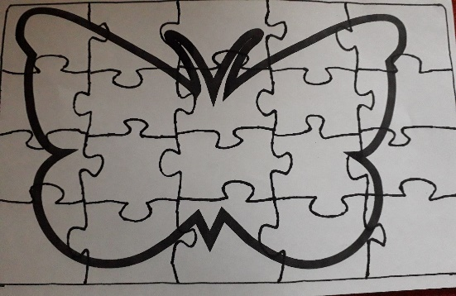
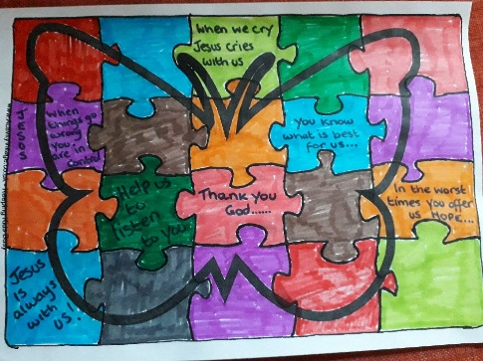

You will need: A copy of the jigsaw template (below), pens or colouring pencils

When Jesus, heard that his friend had died, he cried.
Sometimes when we are sad and feel like crying, it can feel like things will never be the same again, everything is broken there is no hope.
When Lazarus died Mary and Martha, his sisters, felt that Jesus had let them down by not coming straight away.
Have you ever felt left down by a friend?

Jesus promises us that he will be with us always. He will never let us down.
Colour the picture of the butterfly. You can write some words or draw pictures on the pieces of the jigsaw, saying thank you, or sorry, or names of people or places you want to pray for.

Cut out the pieces of the jigsaw and as you put the pieces together give thanks that even when we feel broken Jesus can put all the pieces back together again. Jesus brought new life to Lazarus and can bring new everlasting life to us all.

Play Dough Mat

Print out the play dough mat (below) and laminate it for future use. Use the mat to explore things that make you sad and things that amaze you.
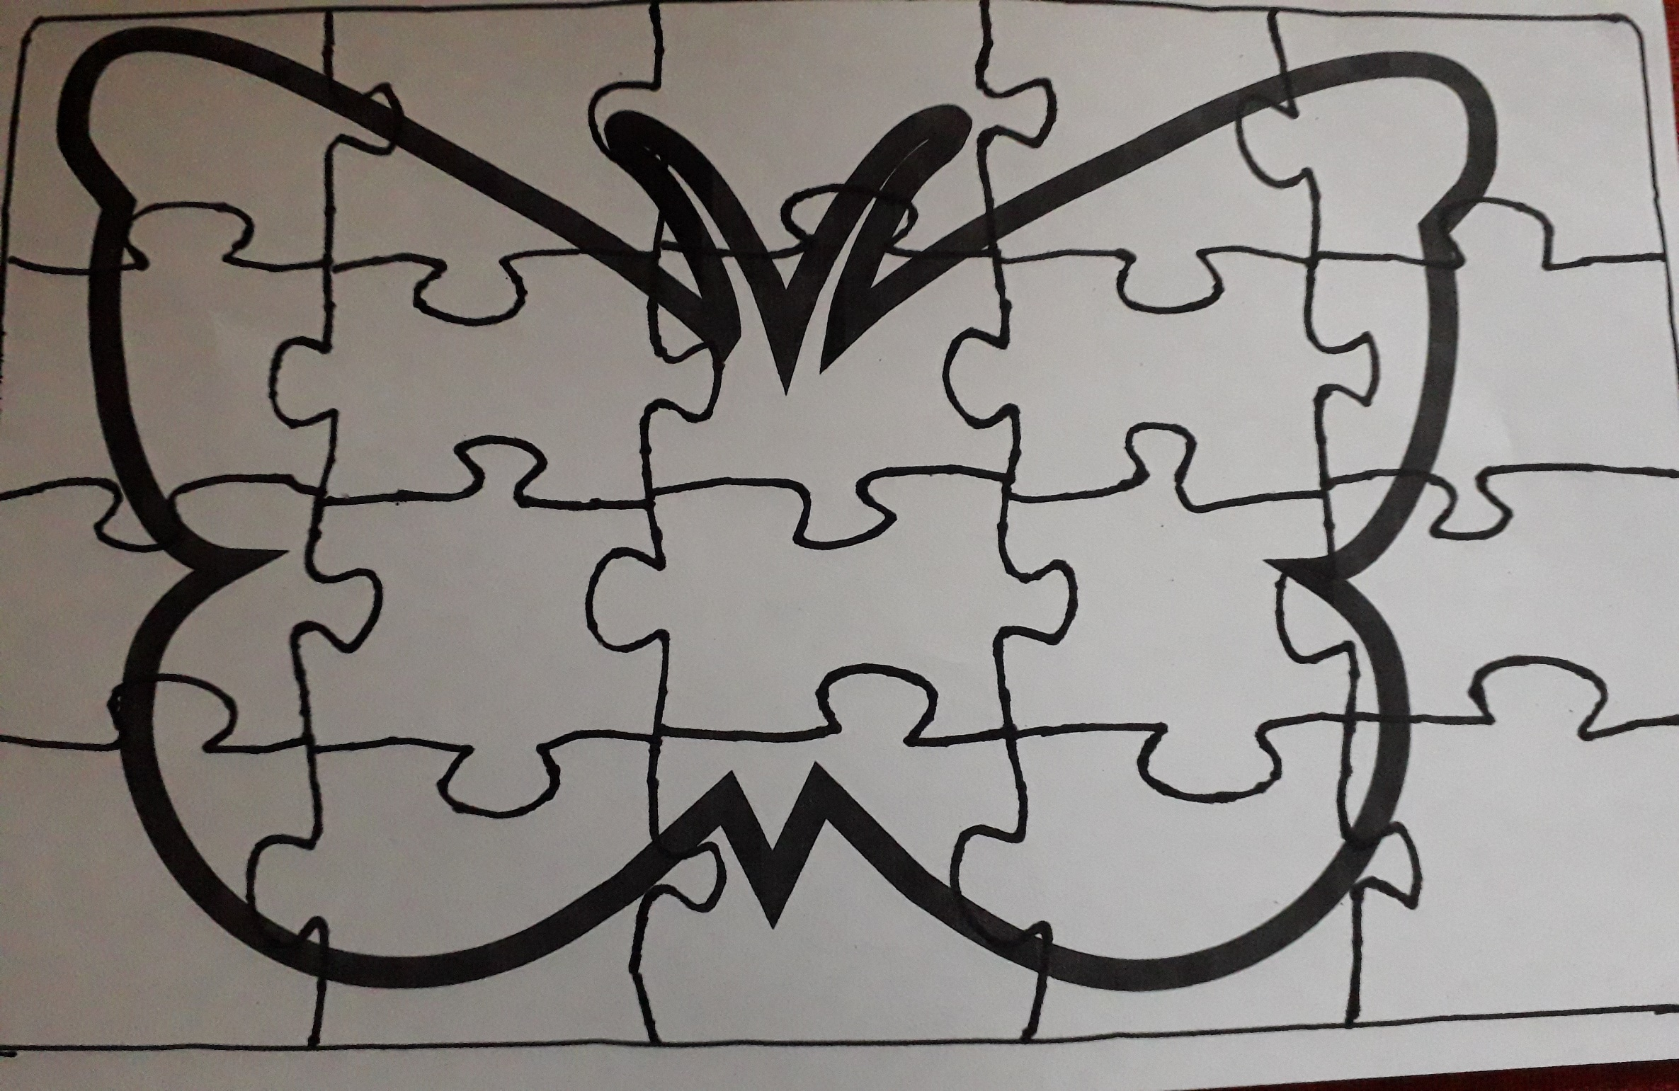
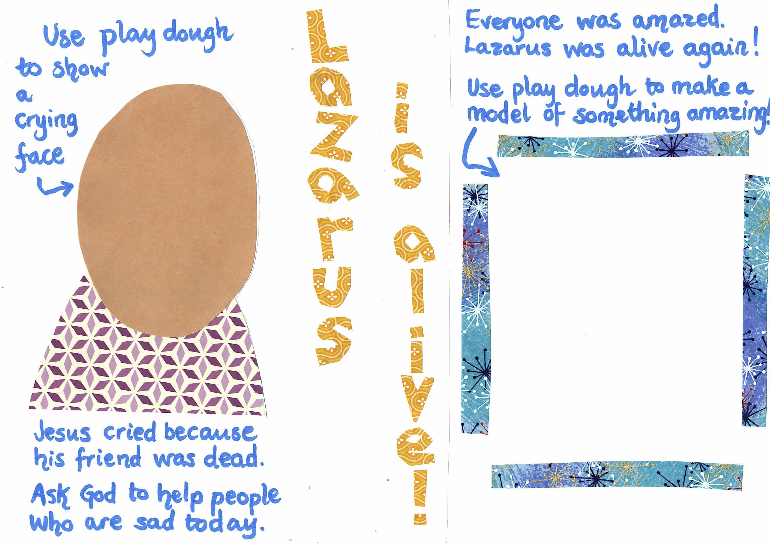

The Death of Lazarus

Lazarus was sick. His sisters, Martha and Mary, were worried. They sent word to Jesus to tell him that his friend was very ill. When he heard, Jesus said: “Death will not be the end of his illness. This is happening so that people will see God’s glory.” Nobody was sure what he meant. Jesus waited for two days and then he made his way to Lazarus’ home.

Meanwhile, in Bethany, Lazarus had died. His sisters cried and wrapped his body in cloth. They put him in a tomb and put a stone across the entrance.

When Jesus arrived at Lazarus’ home, Lazarus has been dead for 4 days. Many people were sad and had come to comfort Martha and Mary. When Martha heard that Jesus was coming, she went out to meet him, but Mary stayed at home.

Martha said to Jesus: “if you had been here, my brother would not have died. ²² But I know that God will give you whatever you ask.”
²⁵ Jesus said to her, “I am the resurrection and the life. Anyone who believes in me will have life, even if they die.” Mary replied, “I know that you are the son of God”
Martha went to tell Mary that Jesus was asking for her, so Mary came to meet him. Lots of other people followed her. They took Jesus to where Lazarus was lying. Jesus saw how upset the people were and he cried with them for his friend.
“Take away the stone,” Jesus said to the people gathered around the tomb. So they took away the stone. Then Jesus looked up and spoke to God, asking that everyone would believe that God had sent him.
⁴³ When he had said this, Jesus called in a loud voice, “Lazarus, come out!”
To everyone’s amazement, Lazarus got up and walked out of the tomb.
Jesus said to them, “Take off the cloths and let him go.
The crowd gathered around the tomb saw all this and believed that Jesus had been sent by God.

