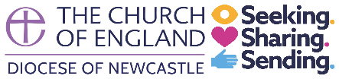

Newcastle Diocese
Social Media Standards of Behaviour
The Communications Team for the Diocese of Newcastle reserve the right to take action if they observe people posting inappropriate, unsuitable or offensive material on Diocesan or our Bishops’ social media accounts. This includes:
- Hiding or deleting comments which are offensive or hateful, either towards other users, the Diocese of Newcastle, its staff and clergy, or our Bishops.
- Blocking or banning people who repeatedly harass Diocesan and Bishops’ social media pages.

