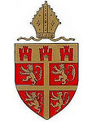 | Officer for Intern Ministry (0.5 FTE)  Diocese of Newcastle
 |  |  |  | 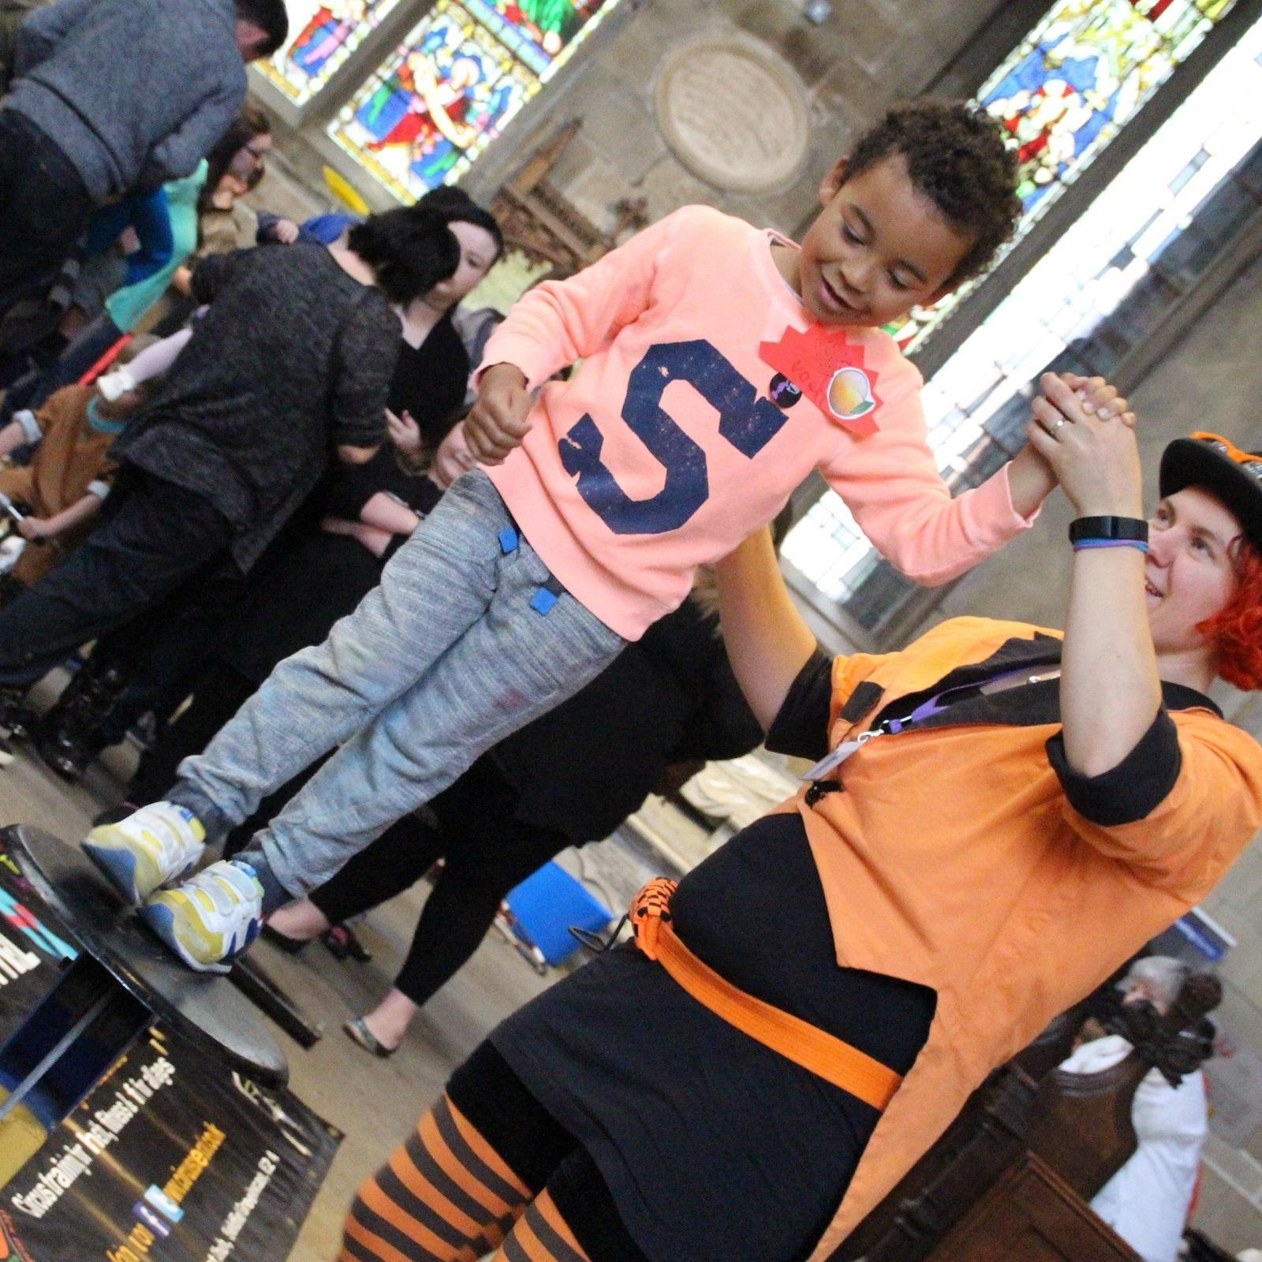

Diocese of Newcastle
www.newcastle.anglican.org
Newcastle Diocesan Board of Finance. A Company Limited by Guarantee and a Registered Charity.
Registered in England number 650977. Registered office: Church House, St John’s Terrace, North Shields NE296HS.
Officer for Intern Ministry
This new post will play a key part in our vision of growing church bringing hope, developing an intern programme which will enable participants to grow as disciples of Jesus Christ and to explore their vocation and ministry. Our ambition is that many of them will go on to serve, lead and help church communities flourish across this diverse area, the land of the ‘Northern Saints’.
As part of the diocesan Mission and Ministry team, you will have responsibility for developing both the Church of England Ministry Experience Scheme (MES) and the New Wine Discipleship Year in the diocese. The New Wine Discipleship Year is based at St Thomas’ in Newcastle City Centre, whilst the Ministry Experience Scheme sees people placed in different churches across the city. Both offer a year long placement, enabling people to serve a local church, gain experience and grow in faith, study theology and explore own vocation. We seek to develop a cohort of motivated interns engaged in discipleship, leadership, community work, evangelism, church planting and pioneer work across the diocese.
Diocesan Background

As a diocese, we are seeking to be open to God’s transforming love, generous with God’s transforming gifts and engaged in God’s transforming love. Our priorities are to bring good news, to grow in Christ and to live faith fully.
Framed by the Rivers Tyne and Tweed the Diocese of Newcastle is the Church of England’s most northerly diocese. This Diocese was formed in 1882 and comprises 172 parishes across 2,110 square miles. The Diocese covers the local authorities of Northumberland, Newcastle, North Tyneside and also small parts of County Durham and Cumbria. The 12 deaneries within 2 archdeaconries serve a population of 800,000 people across a variety of communities ranging from sparse rural to large inner city areas of deprivation.
Led by the Bishop of Newcastle, the Rt Revd Christine Hardman, and the Suffragan Bishop of Berwick, the Rt Revd Mark Wroe , the Diocese of Newcastle is committed to flourishing churches and communities and has developed a vision for growing church bringing hope as part of a response to the challenges faced by the church in our rural, urban and suburban settings.
We face the challenges of today with a trust in God, and an expectation that we have what we need for the work we are being called to do. We anticipate significant changes over the next few years, and this post is a key part of helping us to navigate those changes together with hope. We look to grow in discipleship, in generosity, in recognition of everyone’s gifts and in the imagination we bring to serving our communities. The vision for growing church bringing hope is shaped by our values: open to God’s transforming love, generous with God’s transforming gifts and engaged in God’s transforming mission. Our priorities are Bringing Good News, Growing in Christ and Living Faith Fully.
This post is part of a new team led by the Director of Mission & Ministry which draws together new and existing roles, including: Children & Young People Advisers, Generous Giving Advisers, Continuing Ministerial Formation Officer, Lay Ministry Development Officer, Director of Ordinands, Director of Initial Ministerial Education (4-7), Pioneer Ministry, Spirituality Adviser, and Community Missioners. This team will work collaboratively across the diocese to provide formal and informal support and encouragement, training and development, and resources to support parishes, clergy and the whole people of God as we move into the next stage of growing church bringing hope.

Employment
The successful candidate will be employed by the Newcastle Diocesan Board of Finance.

Location
This post will be located at Church House in North Shields, at St Thomas’ Church in Newcastle City Centre, and other churches across the Diocese.
Accountability and key relationships
- Line Manager: Director of Mission and Ministry
- You will be part of the Diocesan Mission and Ministry team. Other key relationships are with the Resource Church, particularly the Revd Ben Doolan and its Staff Team, New Wine Head of Discipleship Year, the National Ministry Team, particularly the Manager of the Ministry Experience Scheme.

Key Responsibilities
Leadership | - Working closely with the Diocesan Mission and Ministry team, the Resource Church and the Ministry Experience Scheme, to deliver an intern scheme aligned with the vision for the diocese: growing church bringing hope;  - Take an active role in the life of the wider diocese;
Intern programme - training | - Plan and oversee the delivery of all aspects of the intern programme, including organising the teaching (Basic theological skills, communication, team participation, leadership skills, key elements of healthy fresh expressions of Christian Community, Principles and Practices of church planting, skills in faithful improvisation), theological reflection, mentoring, placements and pastoral care;  - Teach sessions as part of the intern teaching programme;  - Take a lead in ensuring pastoral care for interns;  - Pray for the interns and help them discover their long-term vocations, connecting them with the diocesan vocations process;  - Train and support intern line managers, placement supervisors, and mentors.
Intern programme – practicalities | - Implement the recruitment process for interns from advertising (in-house and nationally) through to interviews, implementation of voluntary workers agreements, practical living arrangements;  - Keep the proper governance of the intern programme always under review so as to comply with current legislation and best practice;  - Liaise with the New Wine National Team on implementation of the Newcastle Hub  - Liaise with the national Ministry Experience Scheme manager, ensuring that registration and administration of the scheme conforms to national requirements, processes and reporting.  - Oversee and ensure the provision of practical resources for interns, such as housing and bursaries;  - Manage the budget for interns.  - In consultation with the Diocesan Safeguarding Team, ensure that safeguarding policies and training for the Intern programme follow current best practice and are implemented throughout the different schemes and placements.
Intern programme – partnerships | - Attend meetings of the Diocesan Mission and Ministry team.  - Foster and sustain relationships with churches across the Diocese of Newcastle who would like to partner in the intern programme,  - Be a champion for the intern scheme and for young vocations across the diocese.  - Foster and sustain relationships with other relevant organisations such as Lindisfarne College of Theology, Cranmer Hall, New Wine Discipleship Year and other training providers.  - Attend training events and leadership conferences;

Person Specification - Key Criteria
Skills and experience | Christian experience and knowledge  - A range of involvement and experience in church activities;  - Willingness to work within the authority structures of the Church of England and to work effectively with those from different theological and church traditions, bridging differences in understanding and experience;  - Formal theological qualification;  Intern leader qualities  - A vision for the potential of internships to resource local churches and develop people in discipleship, vocation and leadership;  - A strong commitment to the diocesan priorities of Bringing Good News, Growing in Christ and Living Faith Fully.  - A passion for church growth – spiritual, numerical and missional;  - Excellent teacher;  - Capacity to plan, oversee, and deliver a teaching programme, covering key aspects of theology, discipleship, leadership and ministry;  - Experience of teaching and managing interns (desirable);  - Pastoral and interpersonal skills suited to overseeing a diverse cohort of interns with a range of backgrounds, theological convictions and developmental needs;  - Proven experience of managing staff and volunteers;  Personal qualities  - Strong and effective leadership and strategic skills;  - Proven ability to win the confidence of people and nurture them;  - Committed to modelling healthy spirituality and a passion for the Kingdom of God;  - Track record of working collaboratively;
General | - An Occupational Requirement exists for the post holder to be an active communicant member of the Church of England or of a Church in full communion with the Church of England in accordance with the Equality Act 2010  - A follower of Jesus with a maturing Christian faith.  - Able to handle, with competence, a demanding and varied workload;  - Able to take initiative and work without close supervision;  - Strong interpersonal skills  - Able to communicate well to a wide range of audiences with excellent communication skills, both written and verbal;  - Excellent administrative and organisational skills;  - Ability to manage conflict in an appropriate manner;  - Commitment to continuous professional development.  - Ability to work flexible hours, including Sundays, evening and weekend commitments  - A satisfactory DBS is required for this post

General Conditions

Diversity
We understand the benefits of employing individuals from a range of backgrounds, with diverse cultures and talents. We aim to create a workforce that:
- values difference in others and respects the dignity and worth of each individual;
- reflects the diversity of the nation that the Church of England exists to serve;
- fosters a climate of creativity, tolerance and diversity that will help all staff to develop to their full potential.
We are committed to being an equal opportunities employer and ensuring that all employees, job applicants, customers and other persons with whom we deal are treated fairly and are not subjected to discrimination. We want to ensure that we not only observe the relevant legislation but also do whatever is necessary to provide genuine equality of opportunity. We expect all of our employees to be treated and to treat others with respect. Our aim is to provide a working environment free from harassment, intimidation, or discrimination in any form which may affect the dignity of the individual.
Standards of Behaviour and Conduct
Employees are expected to act at all times with due consideration for others and in a manner befitting their position as employees of the Church and as professionals, whatever their job.
Health and Safety Responsibilities
The Newcastle Diocesan Board of Finance takes Health and Safety at work very seriously and require their employees to familiarise themselves with, and follow, their policy.

Terms and Conditions

Salary | Salary: Grade 3  Probationary period £19,383 pa (£38,766 pa full-time); on completion of probationary period £20,403 pa (£40,806 pa full time).
Pension Contributions | Employees will be automatically enrolled into the Church Workers Pension Fund (CWPF) Pension Builder Classic Scheme. The Newcastle Diocesan Board of Finance contributes 10% of pensionable salary as an employer contribution to the Scheme. This is a non-contributory Scheme and staff may voluntarily contribute to the Scheme if they wish to do so. Employees have a right to opt out of the Scheme after enrolment.
Hours of Duty | The post is offered on a part-time basis working 18.75 hours per week. The post holder must be able to work on Sundays. The post may require availability and attendance at evening and weekend meetings and events. Overtime is not paid but time off in lieu is provided. Lunch and any other breaks are unpaid.
Annual Leave | The leave year runs from 1st January to 31st December. Full-time staff receive 25 days paid leave per leave year exclusive of 8 public holidays and 4 additional holidays approved by the Board. Part-time employees receive a pro rata allocation of holiday.
Contract | The employer is the Newcastle Diocesan Board of Finance. The post is permanent and is subject to a six month probationary period.
Application and Selection Process
Closing date for receipt of applications: midday on Wednesday 16th June 2021. Interviews will be held on Wednesday 30th June 2021.

Please e-mail your completed application form to recruitment@newcastle.anglican.org

